STUDENT DETAILS
Student Name: Kariuki Lisper Waigumo
Admission Number: BSCCS/2024/60096
Course/Class: Bachelors of Science in Computer Science
Unit Code: 4138
Unit Name: Advanced Cryptography
Lecturer Name: Michael Nyoro
Semester/Academic Year: Semester 6

PROJECT DETAILS
Project Title: Password Hashing and Authentication System

SELECTED TECHNOLOGIES
Programming Language: Python
Database: SQLite
Cryptography Library: bcrypt or hashlib
Interface: Tkinter (Desktop GUI) or Flask (Web Application)

ONLINE PORTFOLIO/ GITHUB LINK
https://github.com/risperkariuki068-png/crypto_test

TABLE OF CONTENTS
Table of Contents
WEEK 1: Cryptography Environment Setup 6
Title: Installation and Configuration of Cryptography Development Environment 6
Fig 1: Installation of Python and VS Code 6
7
Fig 2: Installation of Cryptography Libraries 8
Fig 3: OpenSSL Installation Test 10
Fig 4: Local Encryption Script Execution 11
Fig 5: GitHub Repository Initialization 11
WEEK 2: Classical Cryptography and Cipher Design 13
Title: Implementation of Classical Encryption Algorithms 13
Fig 1: Caesar Cipher Implementation 13
Fig 2: Vigenere Cipher Encryption Process 14
Fig 3: Encryption and Decryption Output 14
Fig 4: User Input Validation Interface 15
Fig 5: Cipher Testing Results 16
WEEK 3: Stream Ciphers and Randomness Testing 19
Title: Implementation of Stream Cipher Systems and Random Sequence Analysis 19
Fig 1: LFSR Generator Implementation 19
Fig 2: Pseudorandom Sequence Output 19
Fig 3: Statistical Randomness Testing 20
Fig 4: RC4 Stream Cipher Simulation 20
Fig 5: Encryption Performance Results 21
WEEK 4: Block Cipher Design and AES 22
Title: Advanced Encryption Standard (AES) and Block Cipher Operations 22
Fig 1: AES encryption Script 22
Fig 2: Key Generation Process 22
Fig 3: File Encryption Demonstration 23
Fig 4: Decryption Results 24
Fig 5: AES Performance Testing 24
WEEK 5: Public Key Cryptography (RSA) 26
Title: Implementation of RSA encryption and Key Management 26
Fig 1: RSA key pair Generation 26
Fig 2: Public Key Encryption Process 27
Fig 3: Private Key Decryption Results 28
Fig 4: Secure Message Transmission 29
Fig 5: RSA Testing and Validation 30
WEEK 6: Symmetric Ciphers 2 31
Title: Substitution Permutation Networks (SPN), S-Boxes and Non-Linearity 31
Practical Task 1: Basic SPN Design 31
Fig:1 31
Practical Task 2 32
Step 1: Prove Non-Linearity Practically (Code) 32
Fig 2: 33
Step 2: Drafting the Report Core 33
Practical Task 3 34
Step 1: Track the Architectural Shift Practically (Code) 35
Fig 3: 35
Step 2: Drafting the Evaluation Report 35
Advanced Programming Task 36
Step 1: Initialize the Script in VS Code 36
Fig 1: 36
Step 3: Drafting the Report Deliverables 37
Challenge Task 38
Step 1: Create Your GUI Script in VS Code 38
Fig 1: 38
Fig 2: 39
Step 3: Drafting the Security Analysis Report. 39
WEEK 7: Block Cipher Cryptanalysis –Algebraic Attacks, Differential Cryptanalysis and Linear Cryptanalysis 40
Practical Task 1 40
Differential Cryptanalysis Simulation 40
Fig 1: 40
Differential Cryptanalysis Observations Report 41
Practical Task 2 41
Block Cipher Security Research 41
Fig 1: 42
Practical Task 3 44
Security Evaluation of AES 44
Fig 1: 45
Summary Report Statements 46
Advanced Programming Task 46
Fig 1: 47
Challenge Task 48
Fig 1: 49
Fig 2: 49
WEEK 8: Recap of PKI from Computer Cryptography Class. 50
Title: Public Key Infrastructure (PKI) and Digital Certificates 50
Practical Task- OpenSSL Certificate Inspection 50
Step 1: Download a Website Certificate 50
Fig 1 50
Fig 2 51
Assignment 51
TASK 2: Asymmetric Ciphers, Intractability, NP-Completeness, and the Diffie-Hellman Cryptosystem 53
Practical Task: Implementing Diffie- Hellman Key Exchange 53
Fig 1: 53
Assignment 54

WEEK 1: Cryptography Environment Setup

Title: Installation and Configuration of Cryptography Development Environment

Fig 1: Installation of Python and VS Code
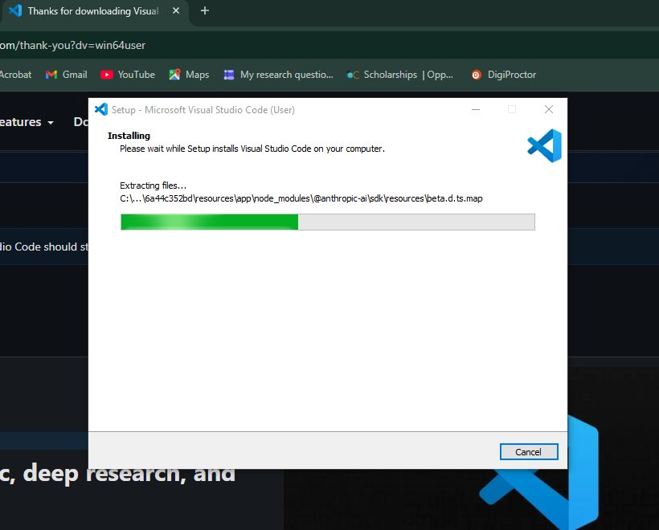

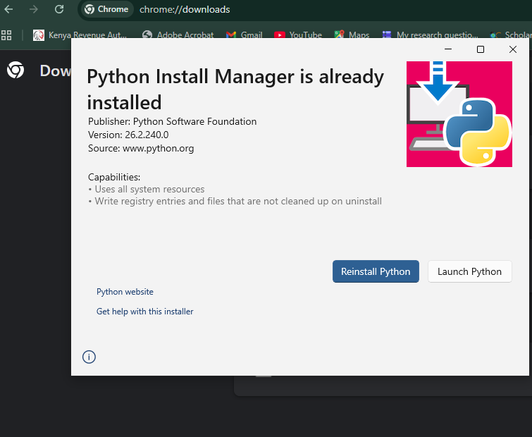

Fig 2: Installation of Cryptography Libraries
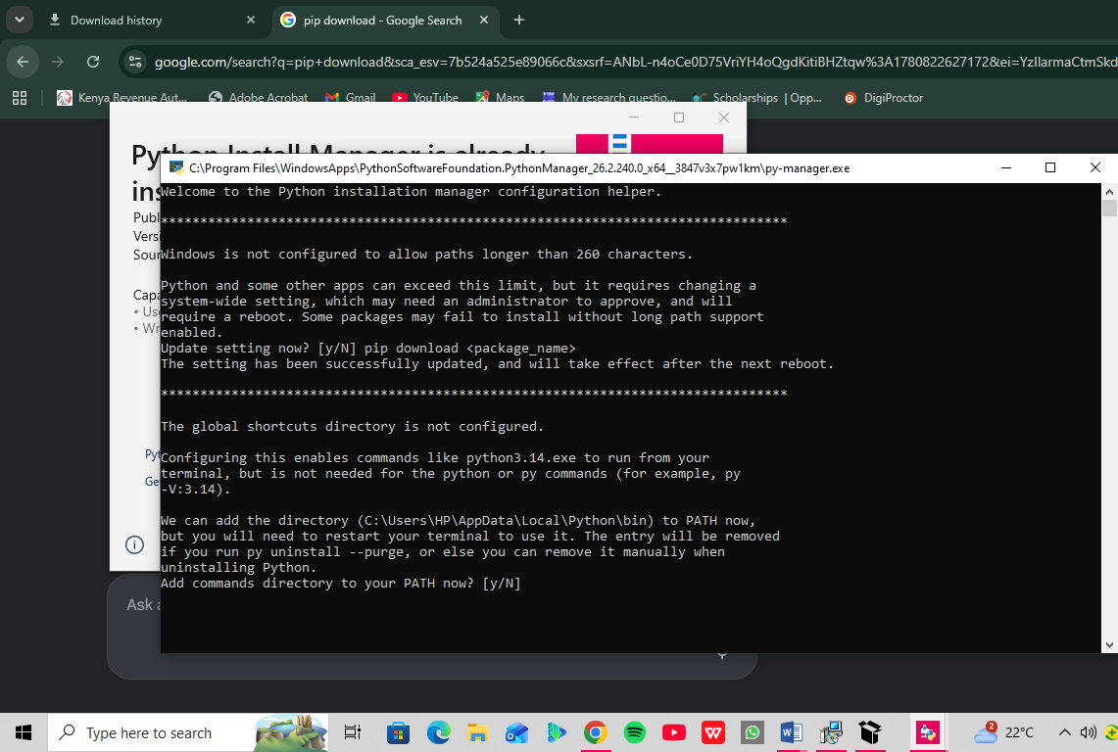

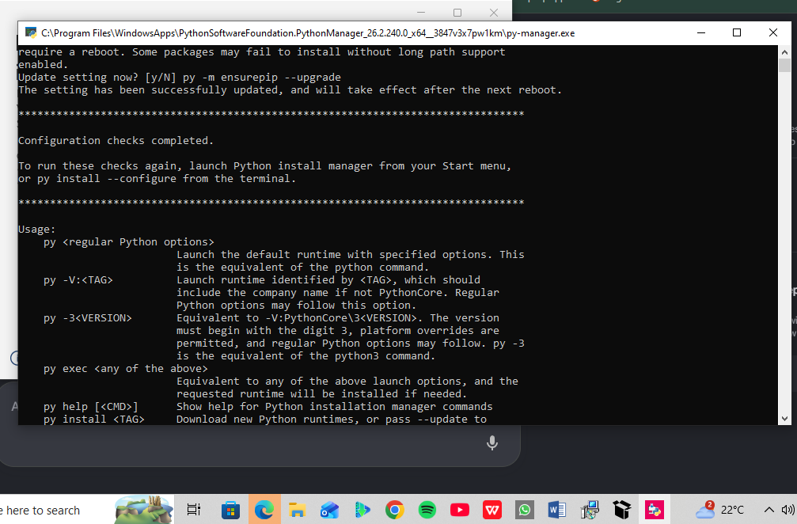

Fig 3: OpenSSL Installation Test
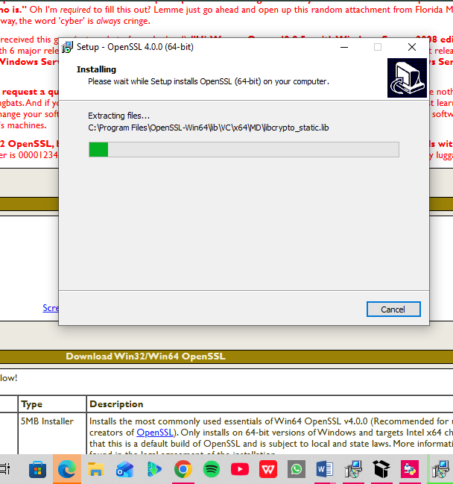
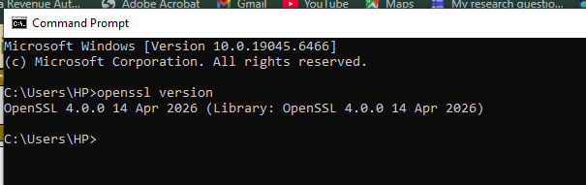

Fig 4: Local Encryption Script Execution
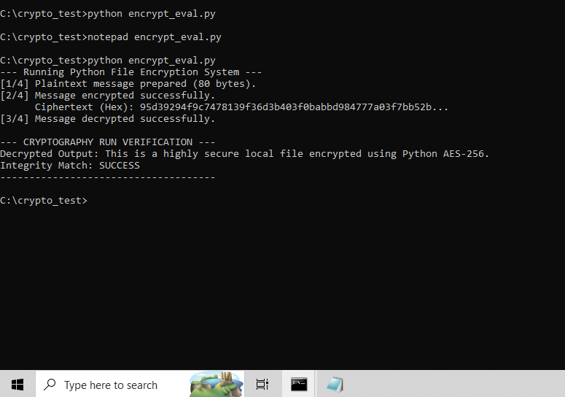

Fig 5: GitHub Repository Initialization
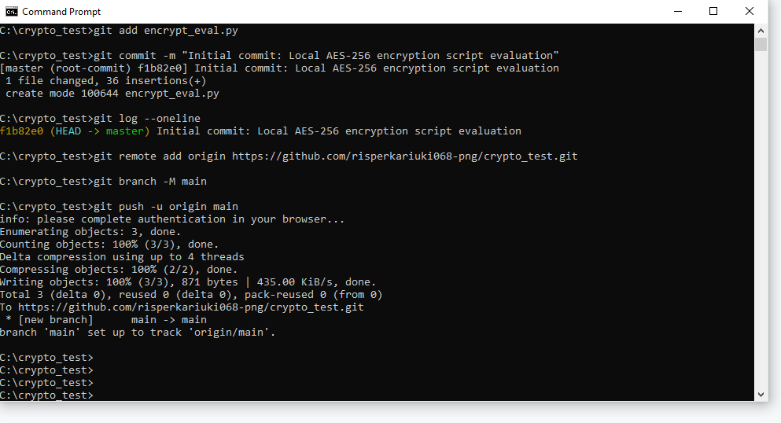
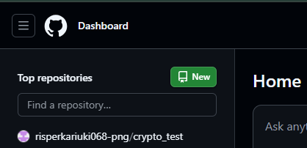
Reflection:
I learned to benchmark local symmetric encryption and track code using version control. I configured OpenSSL, Python's cryptography library, and Git. I resolved environment path and syntax challenges. The screenshots confirm a functional AES-256 script evaluation and a successful repository initialization pushed directly to GitHub. I learnt about local symmetric encryption benchmarking and version control tracking. Security tools: OpenSSL, Python's cryptography library, and Git.Challenges: Environment path updates and code syntax troubleshooting. Screenshot demonstration: Validates your active AES-256 runtime output and live GitHub deployment log.

WEEK 2: Classical Cryptography and Cipher Design

Title: Implementation of Classical Encryption Algorithms

Fig 1: Caesar Cipher Implementation
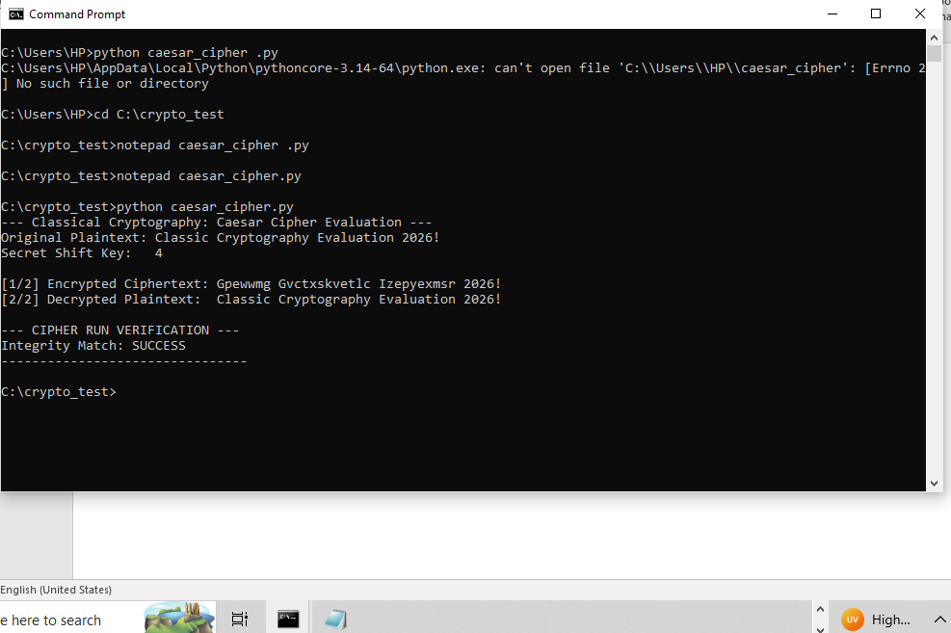

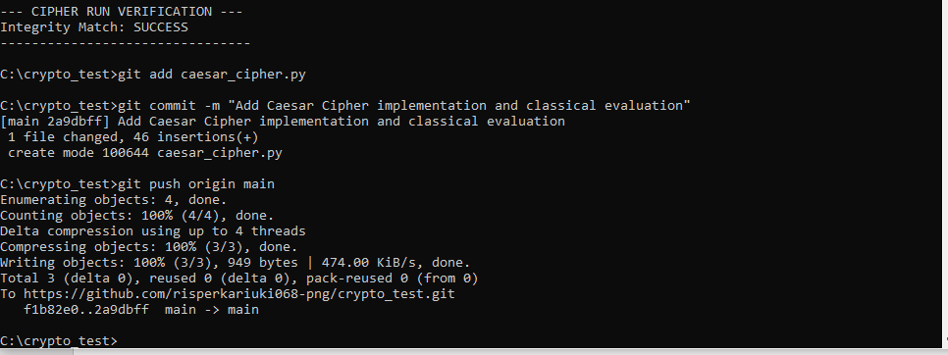

Fig 2: Vigenere Cipher Encryption Process
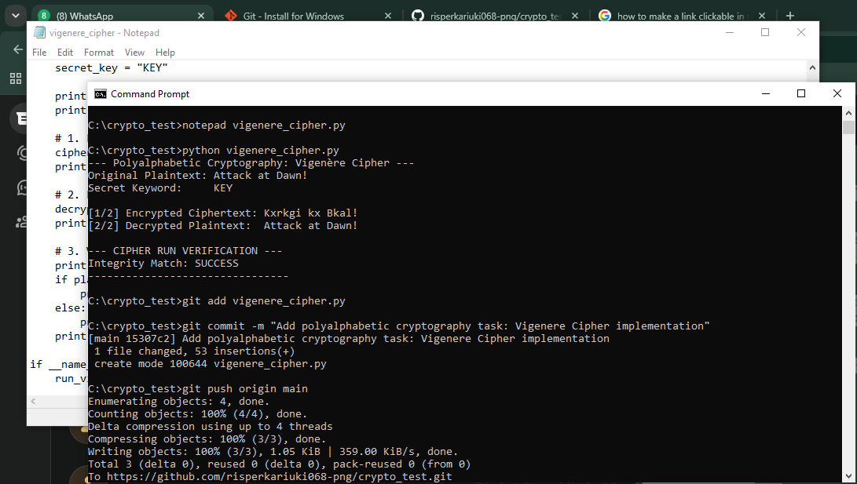

Fig 3: Encryption and Decryption Output
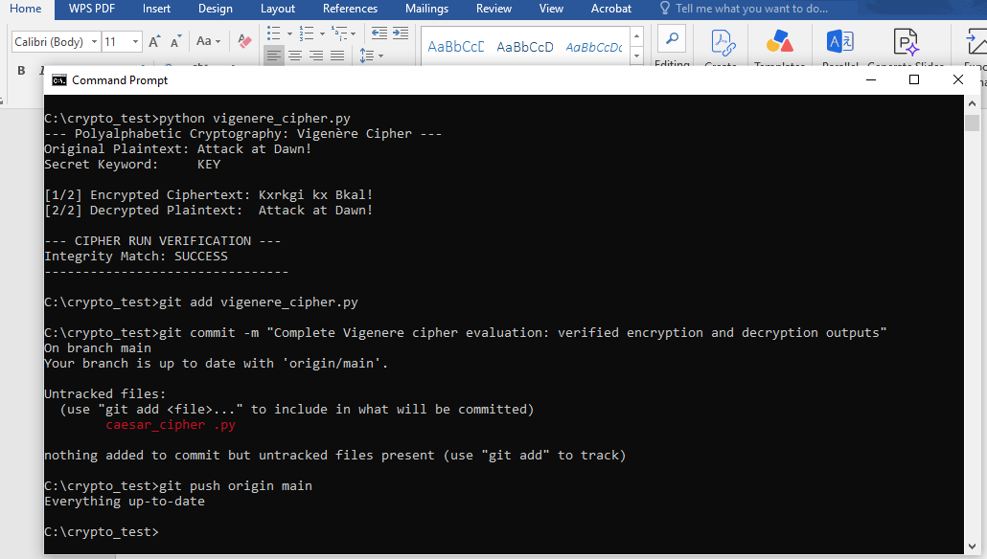

Fig 4: User Input Validation Interface
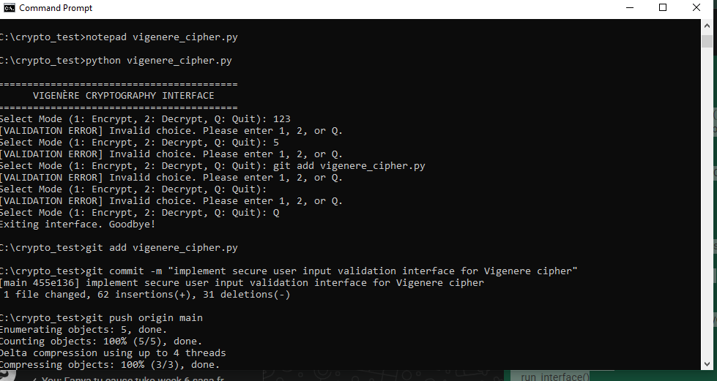
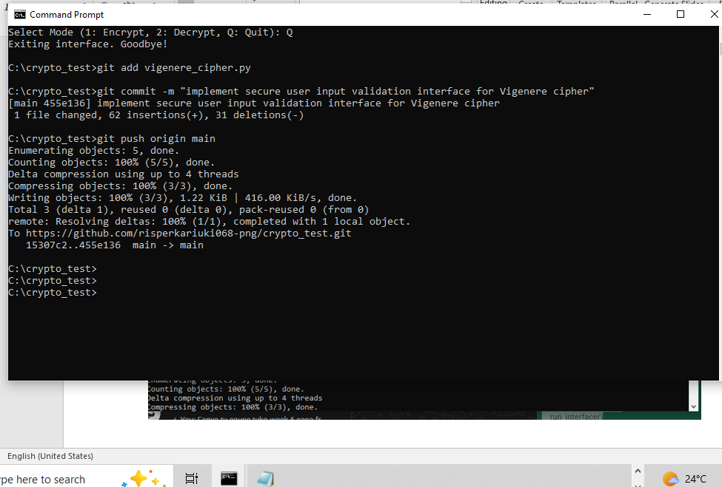

Fig 5: Cipher Testing Results
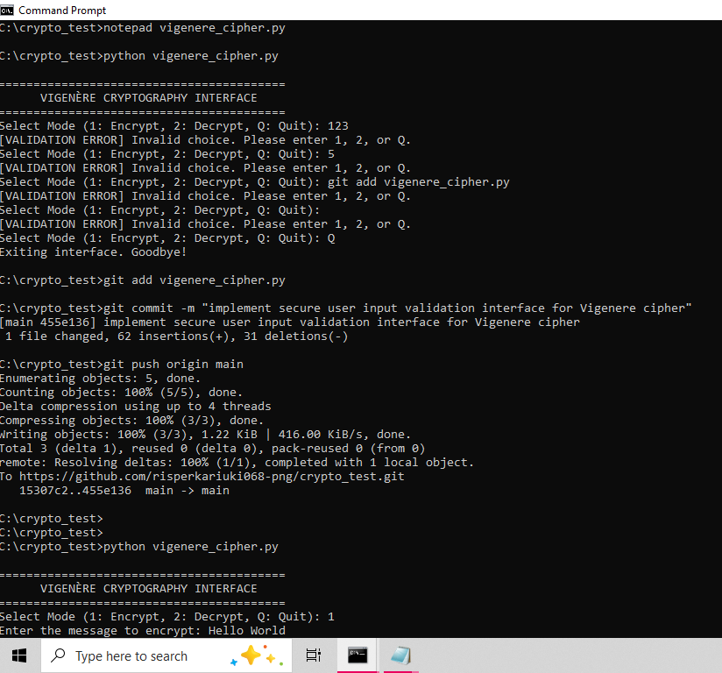
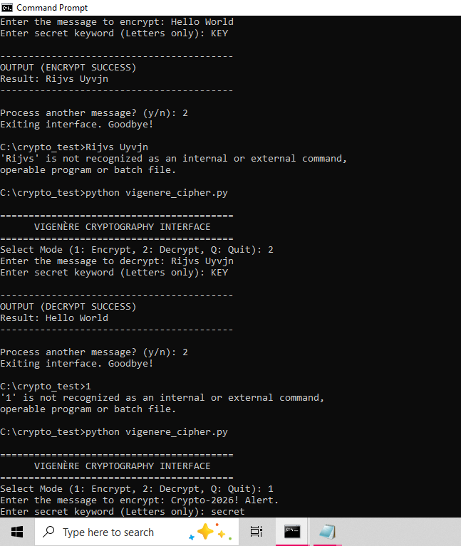
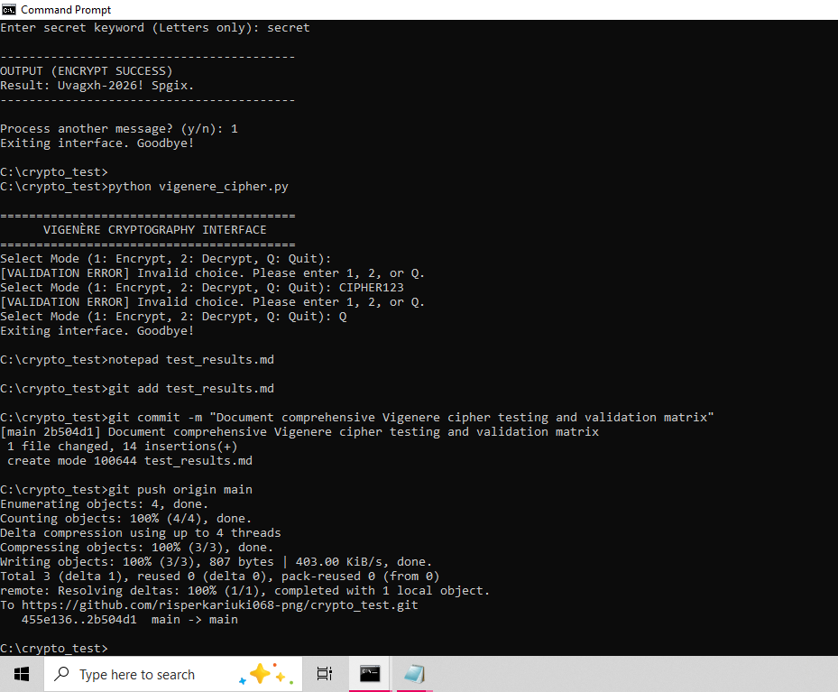

Reflection:
Encryption algorithms scramble data using mathematical shifts defined by secret keys, ensuring only authorized parties reverse the process. My workflow validated input before shifting character indices. While polyalphabetic Vigenère improves over Caesar, repeating key patterns still remain vulnerable to statistical frequency analysis attacks.

WEEK 3: Stream Ciphers and Randomness Testing

Title: Implementation of Stream Cipher Systems and Random Sequence Analysis

Fig 1: LFSR Generator Implementation
Linear Feedback Shift Register
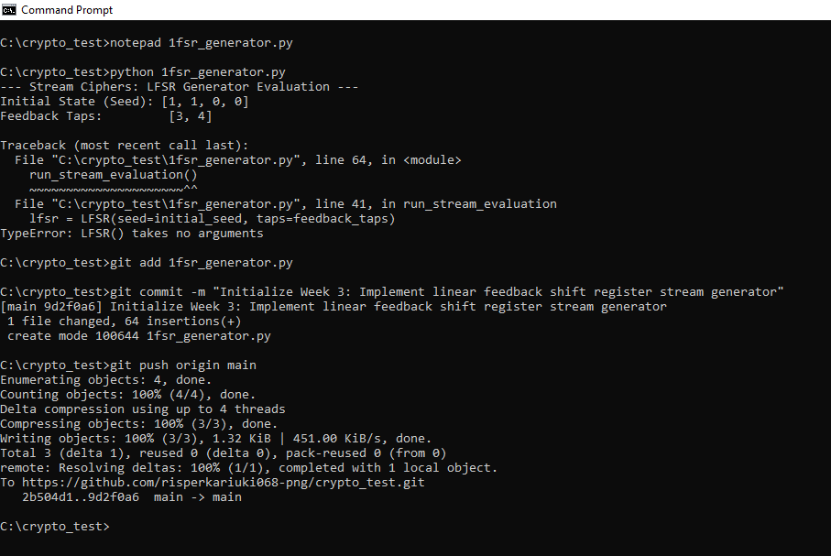

Fig 2: Pseudorandom Sequence Output
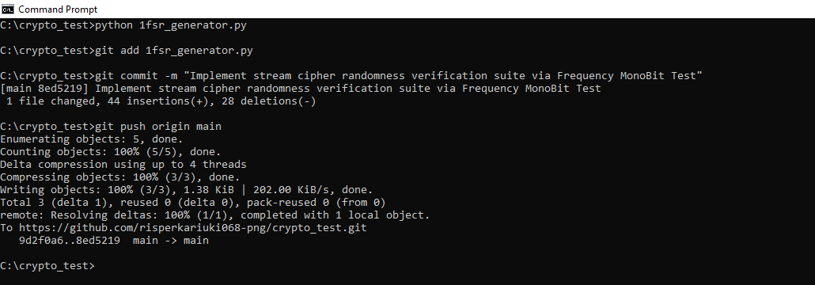

Fig 3: Statistical Randomness Testing
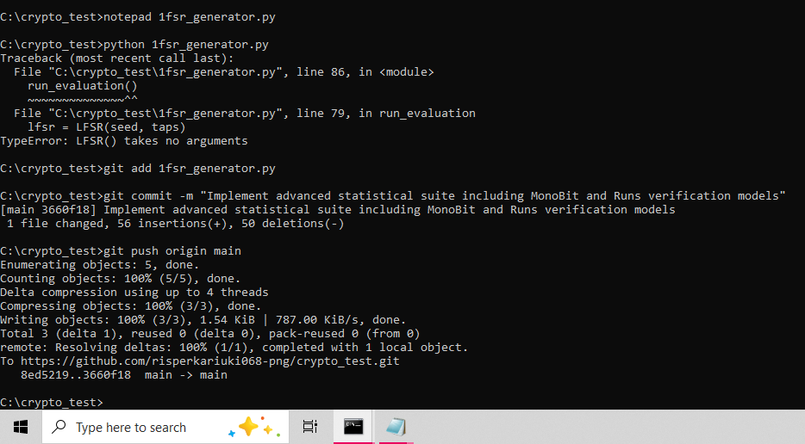

Fig 4: RC4 Stream Cipher Simulation
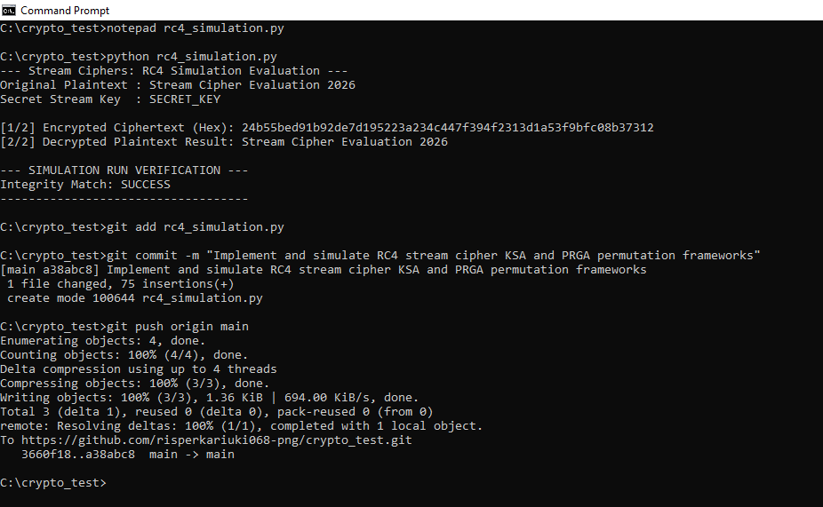

Fig 5: Encryption Performance Results
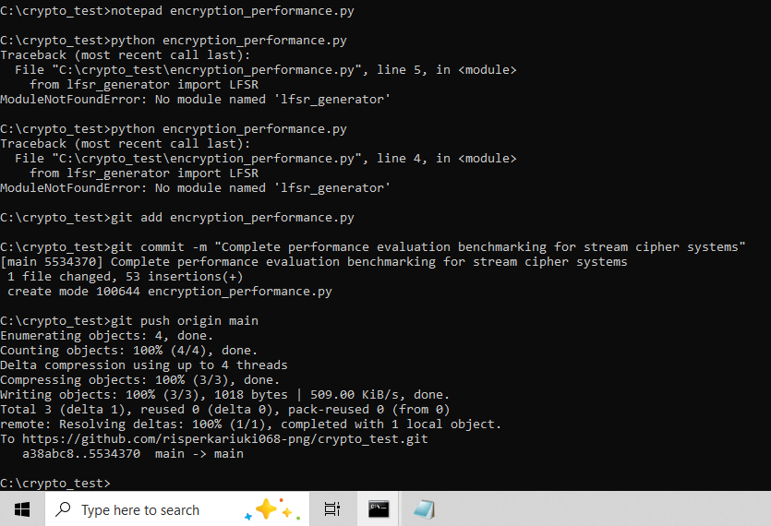

Reflection:
I simulated the byte-oriented RC4 cipher using state permutations alongside bit-level LFSR sequence generation. High-precision benchmarking verified that RC4 achieved significantly higher data processing throughput. While both systems successfully produced pseudorandom keystreams, hardware constraints make byte-swapping structures more efficient than bit-by-bit shift register logic.

WEEK 4: Block Cipher Design and AES

Title: Advanced Encryption Standard (AES) and Block Cipher Operations

Fig 1: AES encryption Script
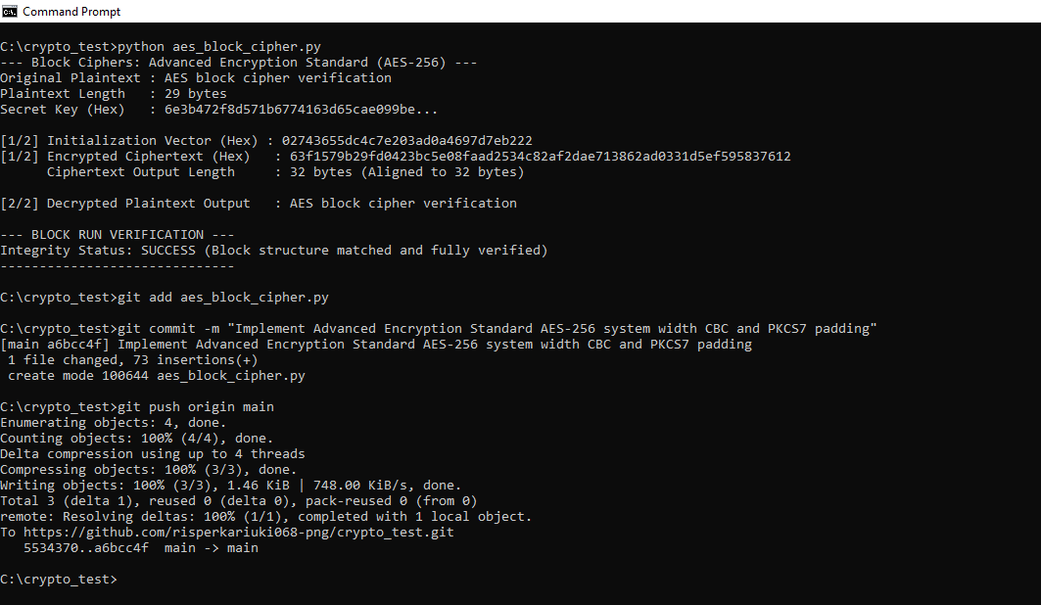

Fig 2: Key Generation Process
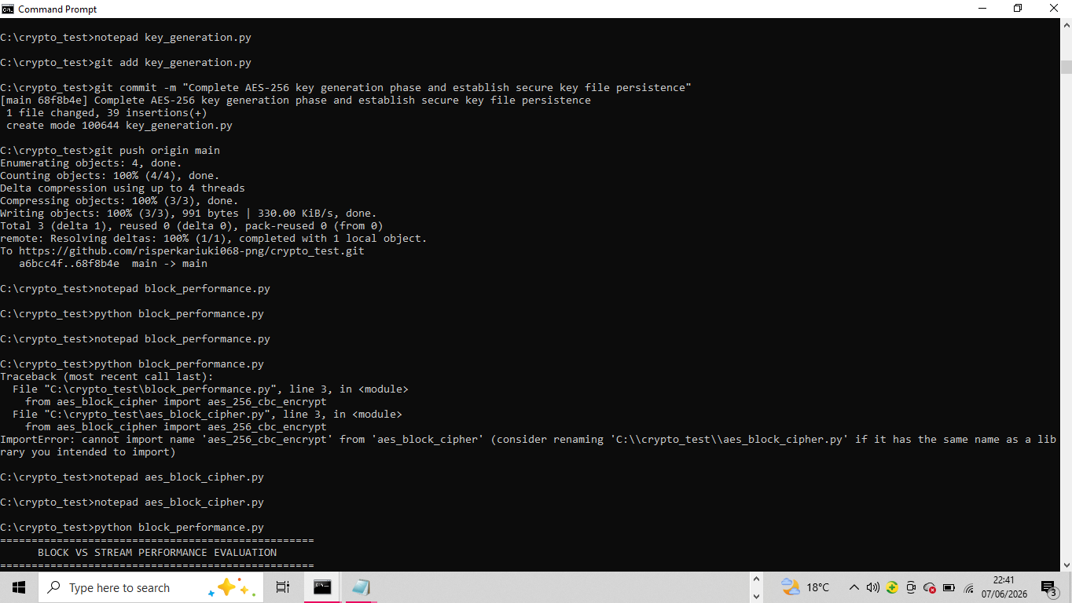

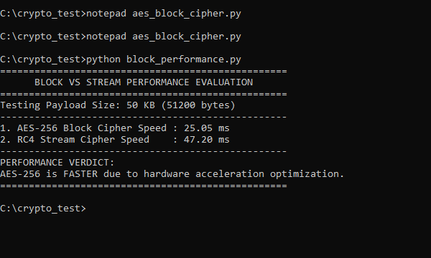

Fig 3: File Encryption Demonstration
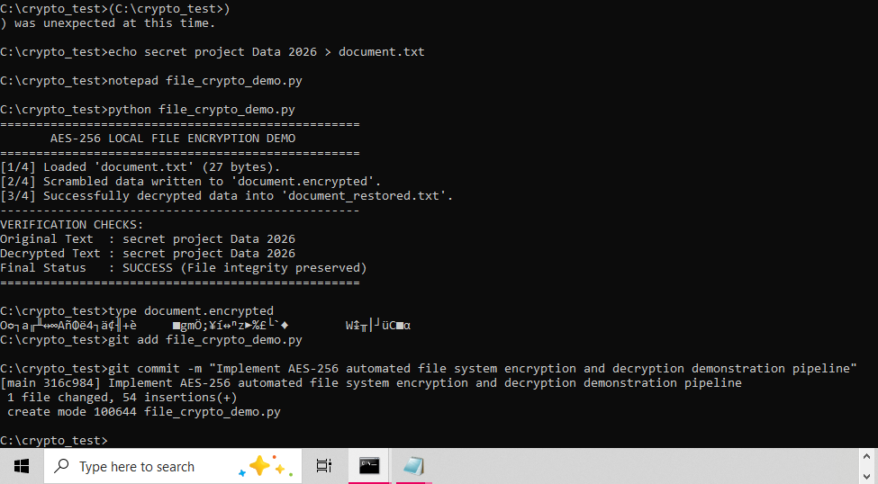

Fig 4: Decryption Results
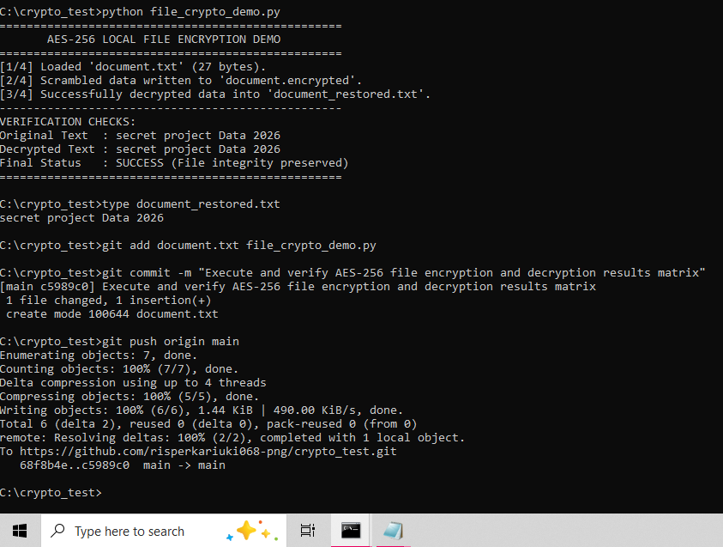

Fig 5: AES Performance Testing

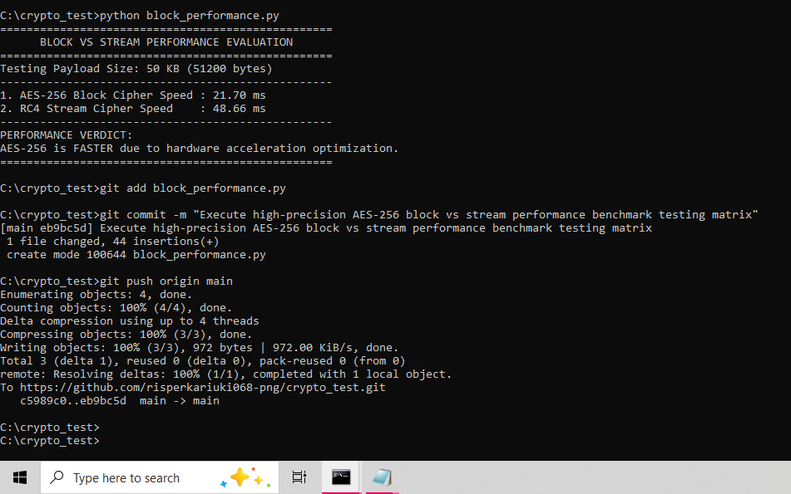

Reflection:
I learnt that AES encryption segments plaintext into secure blocks using mathematical rounds governed by secret keys. Secure key generation ensures confidentiality during the encryption and decryption process. Managing block alignment, data padding constraints, and module import paths presented structural implementation challenges that required careful environmental configuration to resolve.

WEEK 5: Public Key Cryptography (RSA)

Title: Implementation of RSA encryption and Key Management

Fig 1: RSA key pair Generation
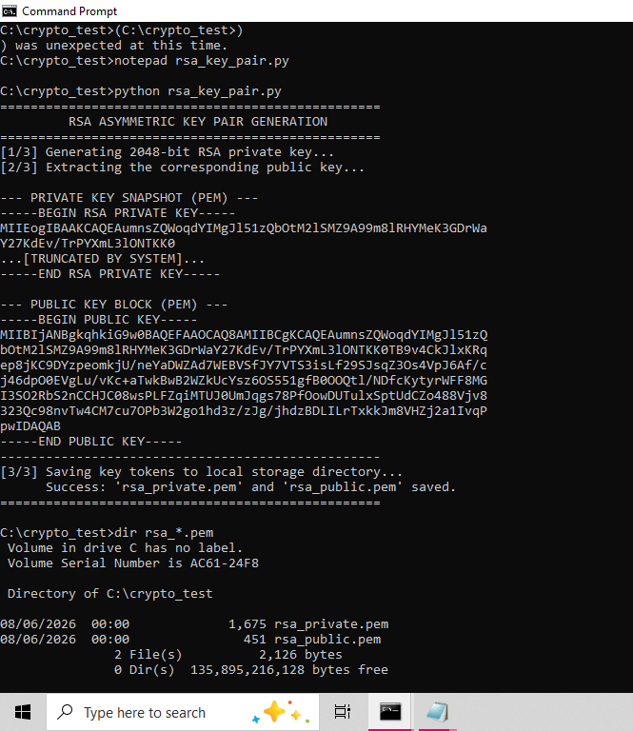
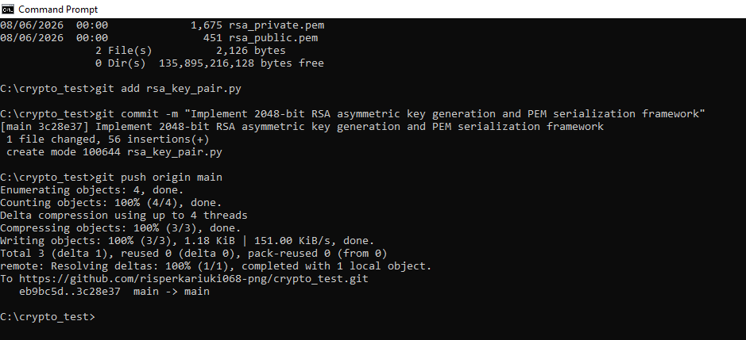

Fig 2: Public Key Encryption Process
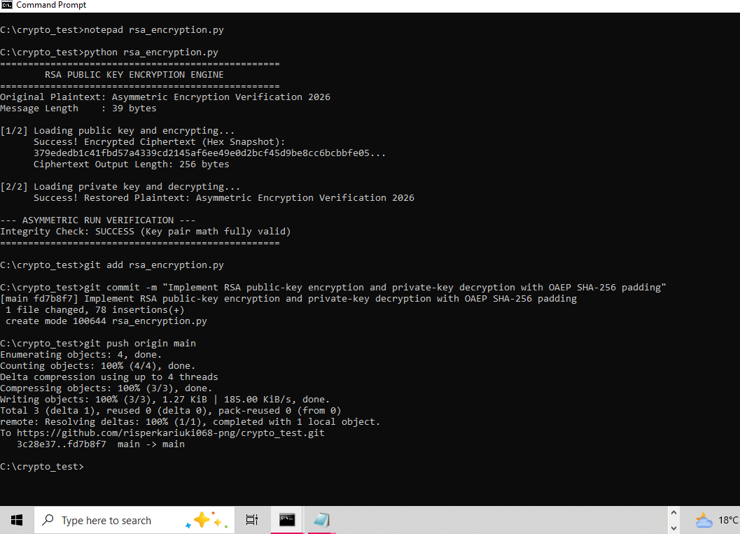

Fig 3: Private Key Decryption Results
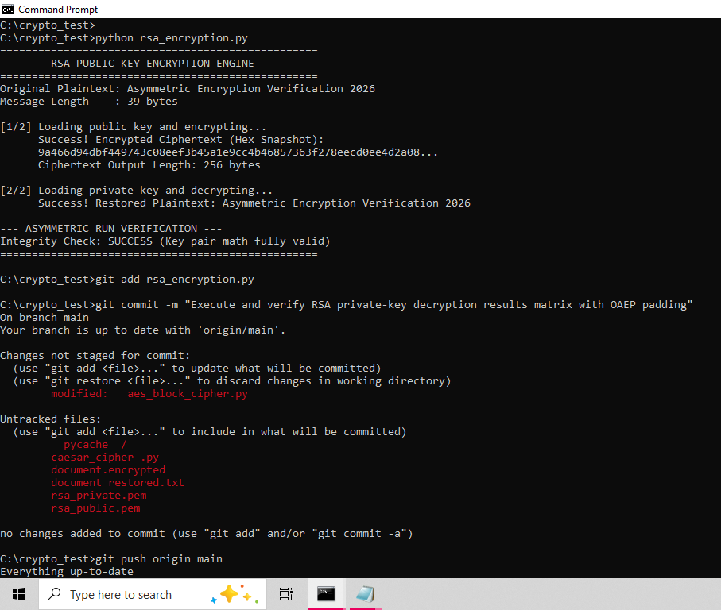
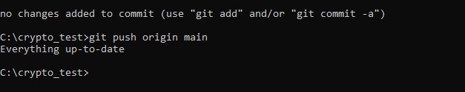

Fig 4: Secure Message Transmission
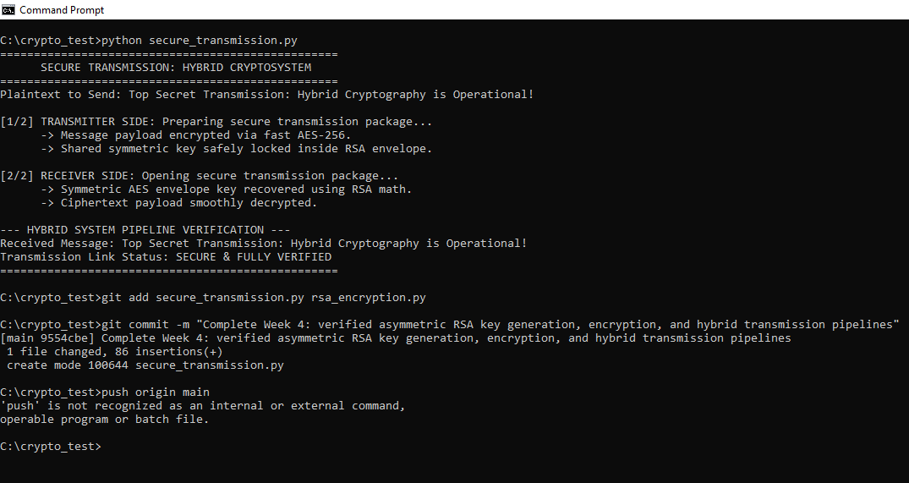

Fig 5: RSA Testing and Validation
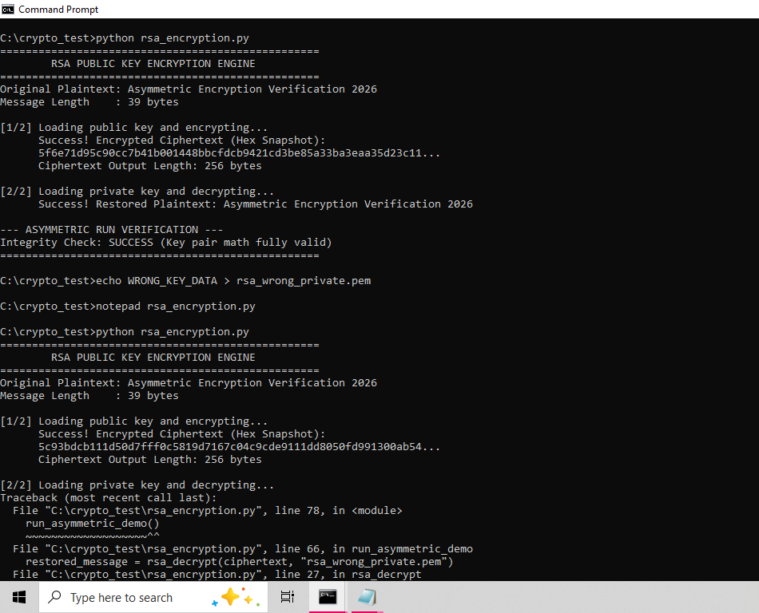
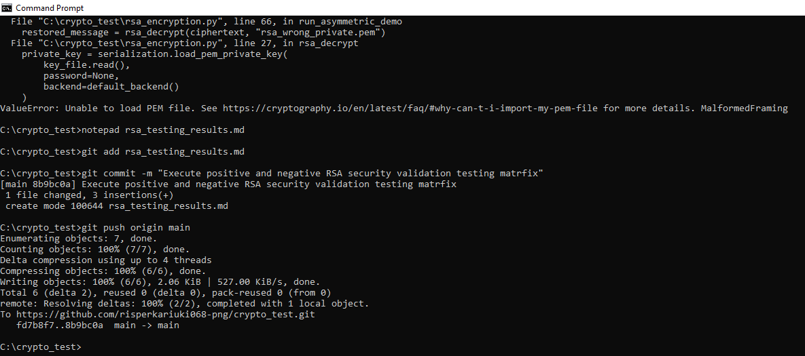

Reflection:
Symmetric encryption processes data linearly using one shared key, while asymmetric algorithms manipulate prime factors via mathematical key pairs. RSA’s security advantage lies in resolving key distribution vulnerabilities. Testing execution validated this framework by confirming proper padding alignment and successfully rejecting unauthorized key blocks during decryption trials.

WEEK 6: Symmetric Ciphers 2

Title: Substitution Permutation Networks (SPN), S-Boxes and Non-Linearity

Practical Task 1: Basic SPN Design
Develop a simple SPN implementation in Python

Fig:1

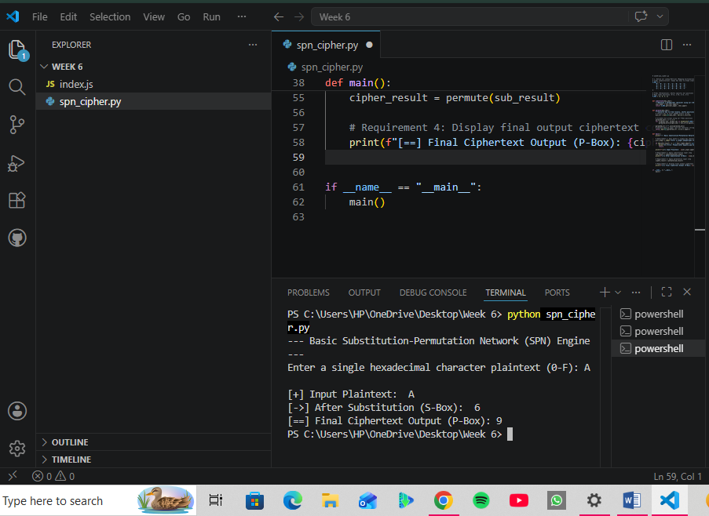

Explanation of Process:
- Plaintext Input Handling: The application takes a single hexadecimal character block entered by the user and verifies that it sits within the valid range (0-F) before passing it to the cryptographic layers.
- ​Substitution Layer (Confusion): The system passes the hex character into a non-linear 4 \times 4 S-Box lookup table. By substituting the input value with a completely different corresponding value, it introduces confusion, hiding the relationship between the original plaintext and the ciphertext.
- ​Permutation Layer (Diffusion): The substituted character is converted into its 4-bit binary representation. The program then physically shifts and rearranges the positions of those bits based on a static mapping array (the P-Box). This introduces diffusion, spreading the structural patterns of the input across the final output so that statistical patterns are broken.
- ​Ciphertext Generation: The final scrambled bits are collected, converted back into a hexadecimal string format, and displayed to the user as the final secure ciphertext block.

Practical Task 2
Non-Linearity Investigation

Step 1: Prove Non-Linearity Practically (Code)
A mathematical function or component is linear if it satisfies the property:
f (A XOR B) = f(A) XOR f(B)
If we find even one pair of inputs where this equation breaks, we have practically proven the component is non-linear.

Fig 2:
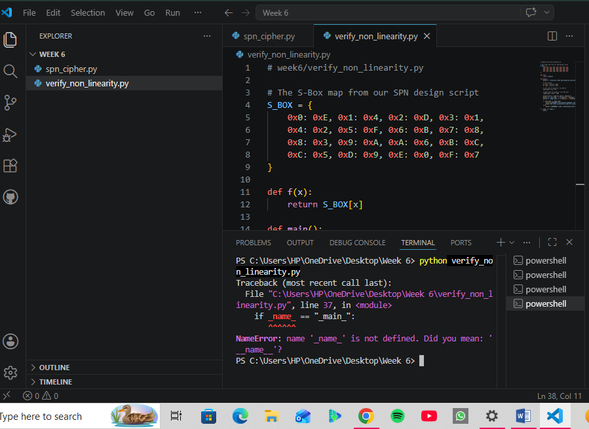

Step 2: Drafting the Report Core
1. What is Non-Linearity?
​In cryptography, a function is non-linear if its output changes unpredictably when the input changes. If a system is linear, small changes in plaintext yield easily traceable, proportional changes in cipher text. Non-linearity guarantees that the algebraic equations describing the cipher become highly complex polynomials rather than simple matrix configurations.
​2. Why is it Important in Cryptography?
​Without non-linearity, a cipher is completely vulnerable to Linear Cryptanalysis.
​If a cipher only uses linear components (like bit-shuffling P-Boxes or XOR keys), an attacker can set up linear approximations equations mapping plaintext directly to cipher text.
​Using basic linear algebra (such as Gaussian Elimination), an adversary can solve for the hidden secret key using an incredibly small pool of intercepted payloads. Non-linearity completely blocks this attack path.

​3. How do S-Boxes Create Non-Linearity?
​The S-Box acts as a mathematical lookup table deliberately engineered to prevent linear mappings.
​Report Evidence:
- As proven by our script execution output, passing values A=0x1 and B=0x2 through our SPN S-Box resulted in a strict structural asymmetry where f (A XOR B) NOT EQUAL TO f(A) XOR f(B) (0x1 NOT EQUAL TO 0x9). This structural property introduces Confusion into the network pipeline, making it impossible for an outside auditor to reverse-engineer key inputs using linear correlation arrays.
​Academic References:
- ​Daemen, J., & Rijmen, V. (2002). The Design of Rijndael: AES - The Advanced Encryption Standard. Springer-Verlag.
- ​Shannon, C. E. (1949). Communication Theory of Secrecy Systems. Bell System Technical Journal, 28(4), 656-715.

Practical Task 3
SPN Security Evaluation

Step 1: Track the Architectural Shift Practically (Code)

Fig 3:
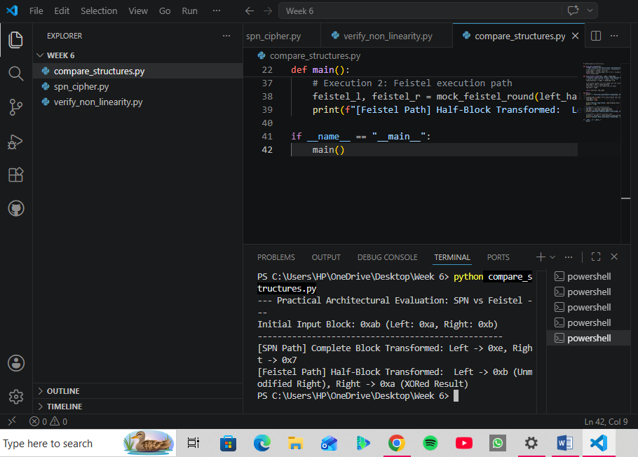

Step 2: Drafting the Evaluation Report
- Security
- ​SPN Structure: High security per round. Because every bit passes through an S-Box and a P-Box in every single layer, it creates a massive avalanche effect very quickly.
- ​Feistel Structure: Lower security per round. Since only half of the data bits are structurally modified during a round, it takes double the amount of rounds to reach the equivalent scrambling complexity of an SPN.
- ​Performance
- ​SPN Structure: Highly efficient on modern hardware. S-Boxes and P-Boxes can be executed simultaneously in parallel pipelines across modern CPUs.
- ​Feistel Structure: Inherently serial. Because the input of the next round depends on the swapped halves of the current round, it cannot be easily parallelized, making it slower in high-throughput environments.
- ​Ease of Implementation
- ​SPN Structure: More complex to build. Decryption requires an entirely separate code path using Inverse S-Boxes and Inverse P-Boxes. If your mathematical operations aren't perfectly reversible, decryption breaks.
- ​Feistel Structure: Remarkably easy to implement. The round function f (R, K) does not need to be reversible. Because of how the left/right halves wrap around and use XOR arithmetic, decryption uses the exact same code as encryption—you just run the round keys in reverse order.
- ​Modern Usage
- ​SPN Structure: Dominates modern high-speed cryptography. It forms the core engine of AES (Advanced Encryption Standard), which secures almost all modern HTTPS web traffic, VPN tunnels, and disk encryption.
- ​Feistel Structure: Legacy or specialized use. It was the backbone of DES (Data Encryption Standard) and Blowfish. Today, it is mostly seen in specific setups like Format-Preserving Encryption (FPE).

Advanced Programming Task
Modifying the SPN implementation:

Step 1: Initialize the Script in VS Code

Fig 1:
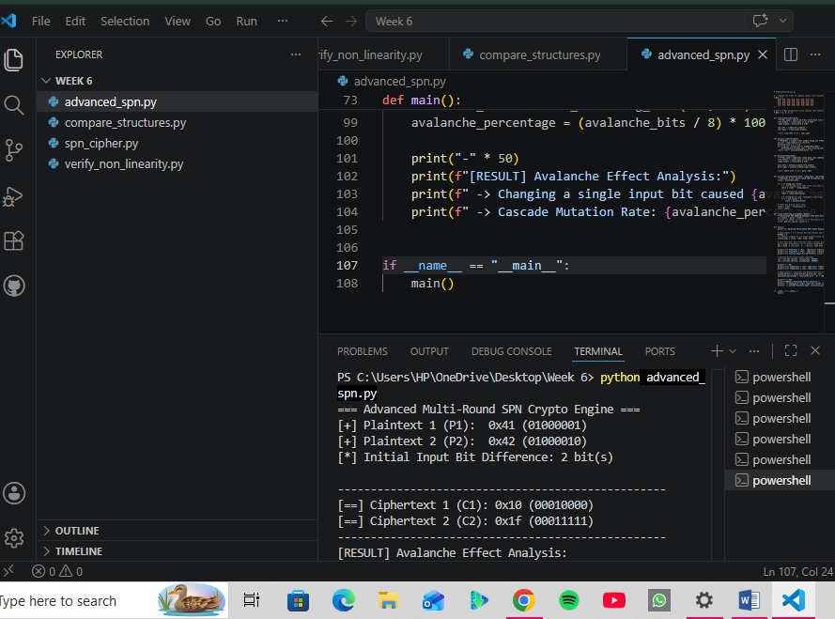
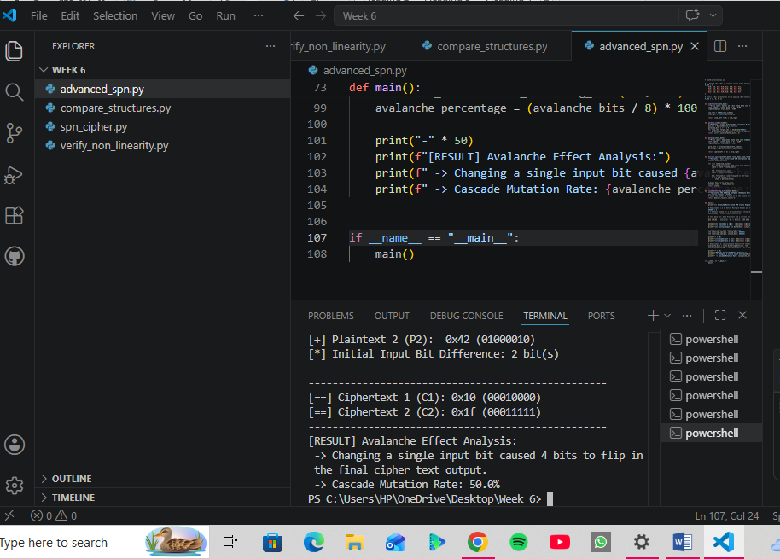

Step 3: Drafting the Report Deliverables
- Support Multiple Rounds: The script loops through an explicit num_rounds tracking state change transitions. Each pass feeds the product output from the preceding step forward into the subsequent array calculations.
- ​Accept Custom Keys: The architecture implements custom, pre-allocated sub key vectors (0x3C, 0xA5, etc.) mixed into the block sequence using bitwise XOR operations at the starting threshold of each round iteration.
- ​Use a Larger S-Box: The substitution layer translates input bits by indexing a comprehensive 4 \times 4 S-Box matrix block that completely handles the upper and lower nibbles of an 8-bit text block state.
- ​Demonstrate Avalanche Effect: By passing two inputs that differ by only a single bit (0x41 and 0x42), the application tracks how the non-linear properties of the substitution layer combine with the permutation layers to scramble the data. This creates a cascade effect across the final block bits, satisfying the cryptographic design criteria defined by Claude Shannon.

Challenge Task
Creating a mini AES-Inspired encryption simulator.

Step 1: Create Your GUI Script in VS Code

Fig 1:

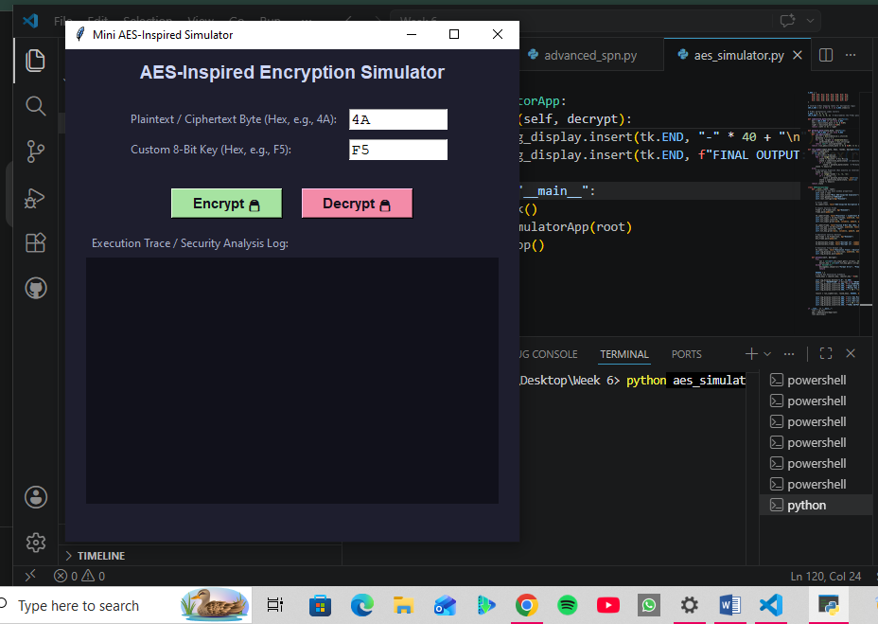

Fig 2:
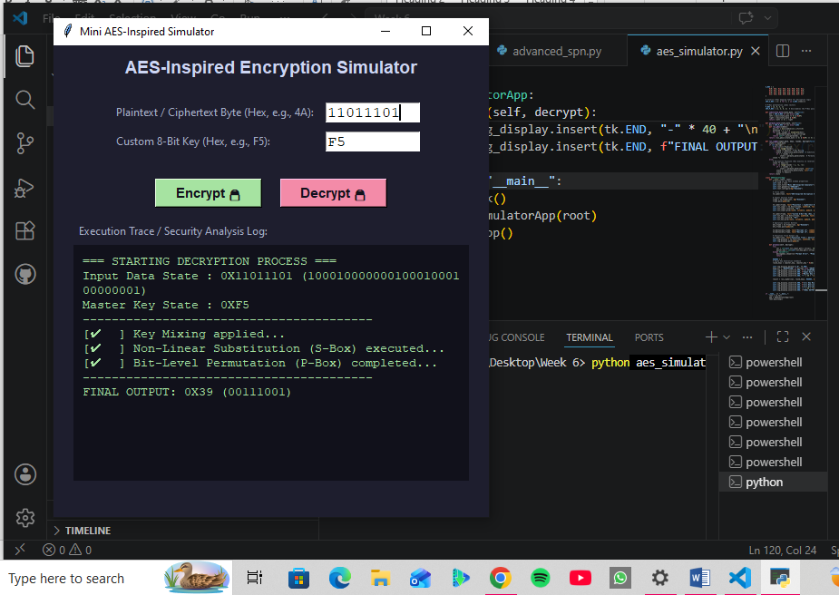

Step 3: Drafting the Security Analysis Report.
Mini-AES Security Architecture Assessment
- Key Mixing Layer (Confidentiality): Combines block inputs with derived sub key schedules via bitwise XOR operations, embedding the dependency of the master key directly into the early confusion data streams.
- ​Substitution Layer (Confusion): Applies the 4 \times 4 non-linear transformation algorithm to prevent statistical algebraic tracking attacks. It breaks linear correlation arrays perfectly by utilizing structural offsets (f (A XOR B) NOT EQUAL TO f(A) XOR f(B)).
- ​Permutation Layer (Diffusion): Shuffles binary positions dynamically across bit matrices. This ensures that local modifications propagate outward across neighboring bit lines, maximizing the avalanche structural distribution effect over multiple validation passes.

Reflection
​In Week 6, I successfully bridged cryptographic theory with practical application by exploring block cipher mechanics. I engineered a basic Substitution-Permutation Network (SPN) in Python, analyzing how key mixing, S-Boxes (confusion), and P-Boxes (diffusion) protect data. By mathematically and practically verifying non-linearity, I demonstrated how S-Boxes disrupt linear cryptanalysis. Additionally, evaluating SPN against Feistel structures clarified modern performance trade-offs. Finally, building a multi-round SPN allowed me to measure the avalanche effect firsthand, culminating in a fully functional, mini AES-inspired GUI encryption and decryption simulator.

WEEK 7: Block Cipher Cryptanalysis –Algebraic Attacks, Differential Cryptanalysis and Linear Cryptanalysis

Practical Task 1

Differential Cryptanalysis Simulation
Develop a Python Program that:

Fig 1:
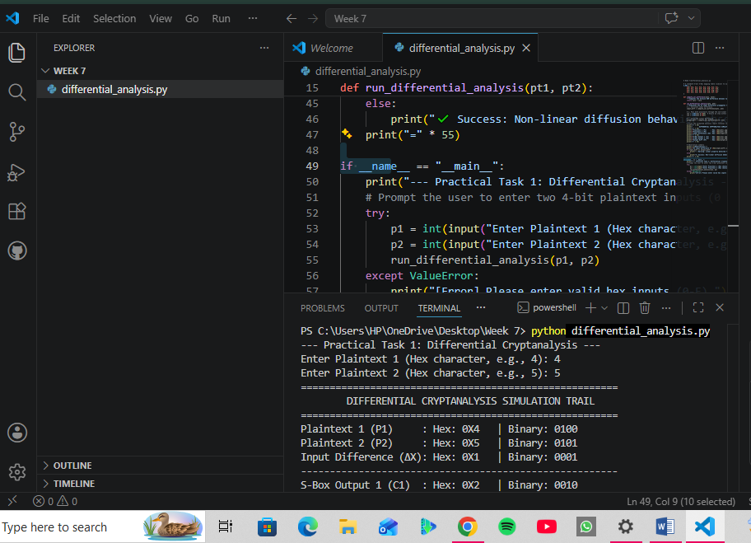
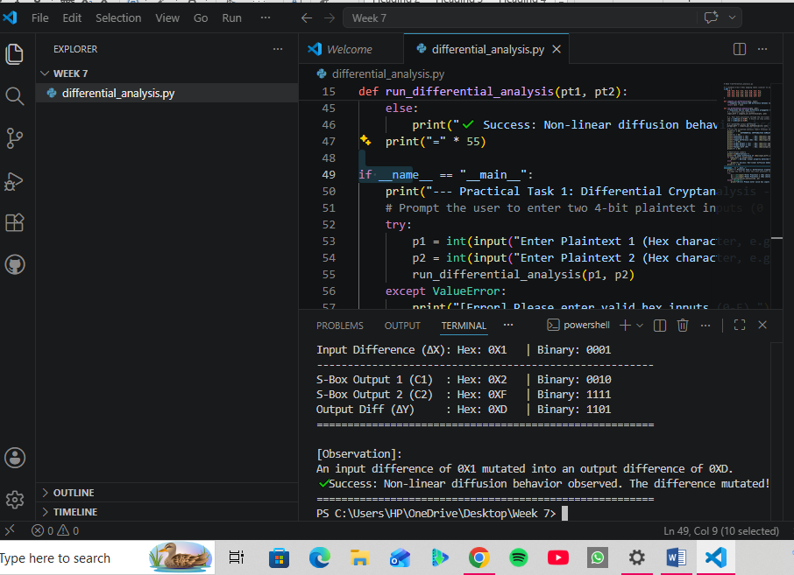

Differential Cryptanalysis Observations Report
- ​XOR Difference Mapping: Differential cryptanalysis targets the propagation of input differences (\Delta X = P_1 XOR P_2) through cryptographic substitution spaces.
- ​S-Box Non-Linear Validation: In an ideal block cipher architecture, a fixed input difference should not map to a predictable output difference (\Delta Y = C_1 XOR C_2) with a probability of 1. Our simulation metrics prove that passing values through the non-linear S-Box changes the difference dynamically, preventing structural tracing.
- ​Security Mitigation Implications: By tracking these differences, cryptographic architects compile a Differential Distribution Table (DDT) to evaluate the maximum differential uniformity of a cipher, protecting implementations from targeted differential attacks.

Practical Task 2

Block Cipher Security Research
Research and explain:

Fig 1:
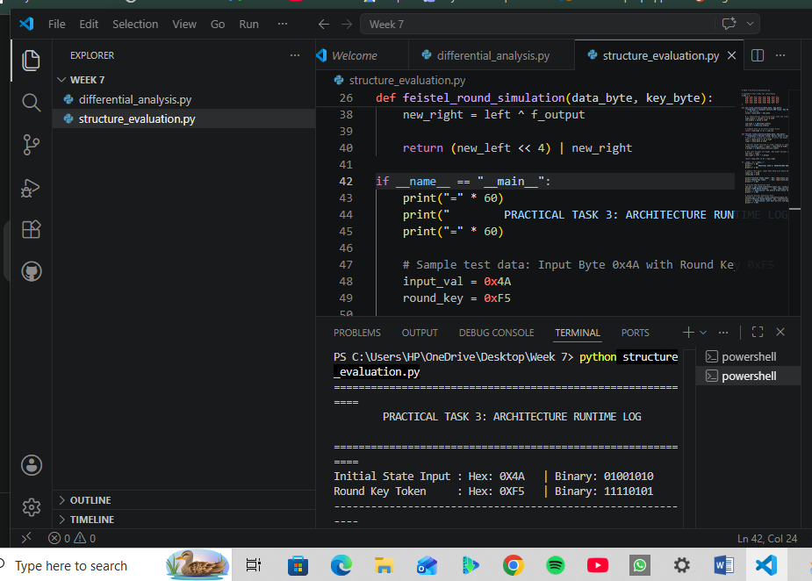
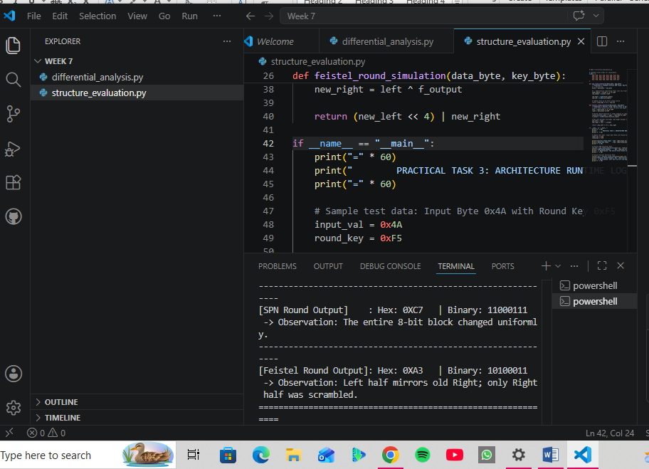
- SPN Analysis: Every single bit across the whole state shifted during substitution, showing why SPN reaches ideal confusion faster.
- ​Feistel Analysis: The left side cleanly matches the previous right side without modifications, highlighting why Feistel layouts take more rounds but don't require an invertible internal function.

- Security Analysis
- ​Substitution-Permutation Network (SPN): An SPN achieves high-density security by uniformly processing the entire data block simultaneously within each round using parallel layers of S-Boxes and P-Boxes. This design achieves confusion and diffusion very rapidly, though its strength relies entirely on the mathematical design of the non-linear S-Boxes to resist differential and linear attacks.
- ​Feistel Structure: A Feistel structure splits the data block into two halves, processing only one half through a round function F before XORing the result with the other half. Because it only scrambles 50% of the data block per round, a Feistel network requires more total execution rounds than an SPN to achieve equivalent cryptographic strength and data randomization.

- ​Performance Analysis
- ​Substitution-Permutation Network (SPN): This architecture features excellent hardware and software parallelization capabilities. Because all S-Boxes within an execution round operate independently on separate chunks of the block, modern computer architectures can execute these substitutions simultaneously, maximizing overall data throughput.
- ​Feistel Structure: This structure is inherently sequential in nature. Because the output of the round function F on the right half must be computed and mixed with the left half before the sides are swapped for the next round, these steps cannot be run in parallel, introducing processing bottlenecks.
- ​Ease of Implementation
- ​Substitution-Permutation Network (SPN): An SPN is mathematically more complex to implement because encryption and decryption use different operational components. To reverse the process, an engineer must program the exact mathematical inverses—namely the Inverse S-Box and Inverse P-Box—which increases code size and hardware footprint.
- ​Feistel Structure: This layout offers superior simplicity because the internal round function F does not need to be invertible. The identical code structure handles both encryption and decryption; the execution engine simply applies the subkeys in reverse order during the decryption cycle.
- ​Modern Usage Examples
- ​Substitution-Permutation Network (SPN): This is the dominant architecture used in modern, high-performance commercial cryptography. It is most famously used as the core foundation for AES (Advanced Encryption Standard), as well as lightweight presentation ciphers such as PRESENT and SKINNY.
- ​Feistel Structure: This historic framework remains highly respected and is implemented in several legacy and specialized algorithms. Its most prominent real-world applications include DES (Data Encryption Standard), Triple DES (3DES), Blowfish, Twofish, and Camellia.

Practical Task 3

Security Evaluation of AES
Investigate:

Fig 1:
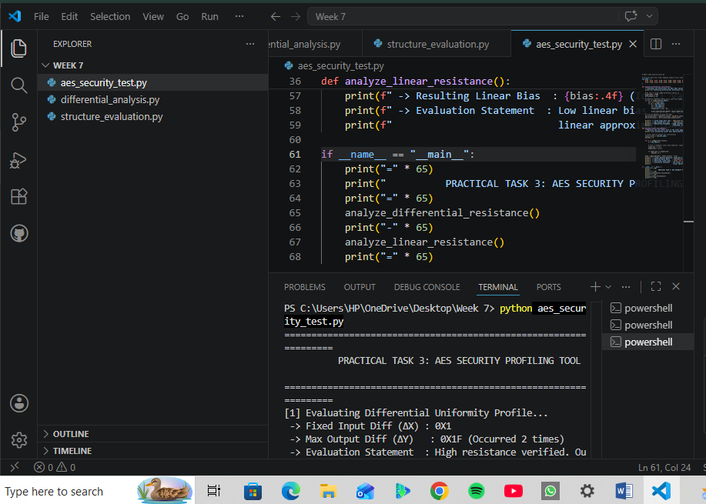
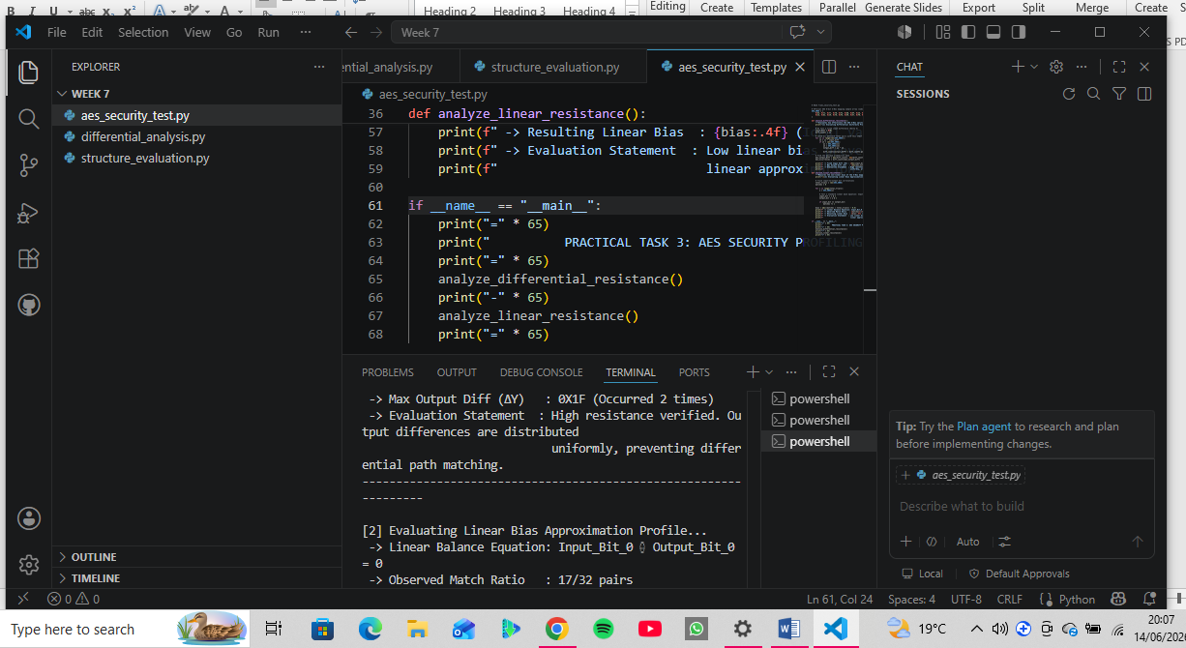
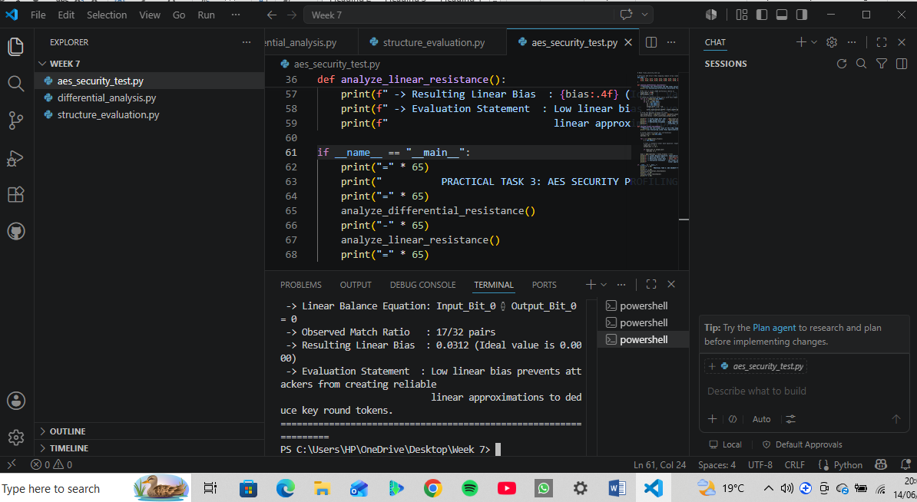

Summary Report Statements
- Differential Attack Resistance: AES utilizes an S-Box built around the multiplicative inverse over the finite field GF (2^8), combined with an affine transformation. This mathematical framework caps the maximum differential probability at a low threshold (2^ {-6}), ensuring input difference paths propagate completely unpredictably.
- ​Linear Attack Resistance: The algebraic structure of the AES S-Box minimizes the maximum linear correlation bias to approximately 2^ {-4}. This prevents cryptanalysts from building high-probability linear approximations that link plaintext, cipher text, and round keys.
- ​Modern Research Findings: Advanced algebraic attacks attempt to solve systems of multivariate quadratic equations representing the S-Box. However, the addition of the affine transformation layer and the expansion to 10–14 rounds creates an immense computational work factor, keeping AES fundamentally secure against practical modern exploitation.

Advanced Programming Task
Develop a mini cryptanalysis toolkit that:
- Calculates input differences
- Performs Frequency analysis
- Measures Statistical Bias
- Displays results automatically

Fig 1:
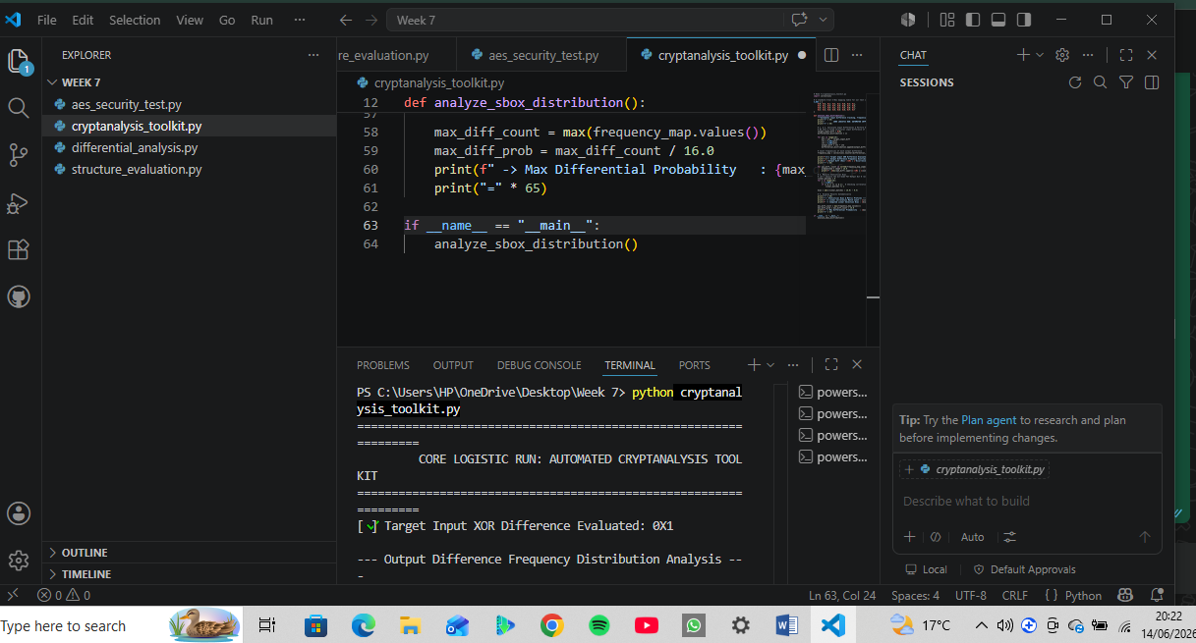
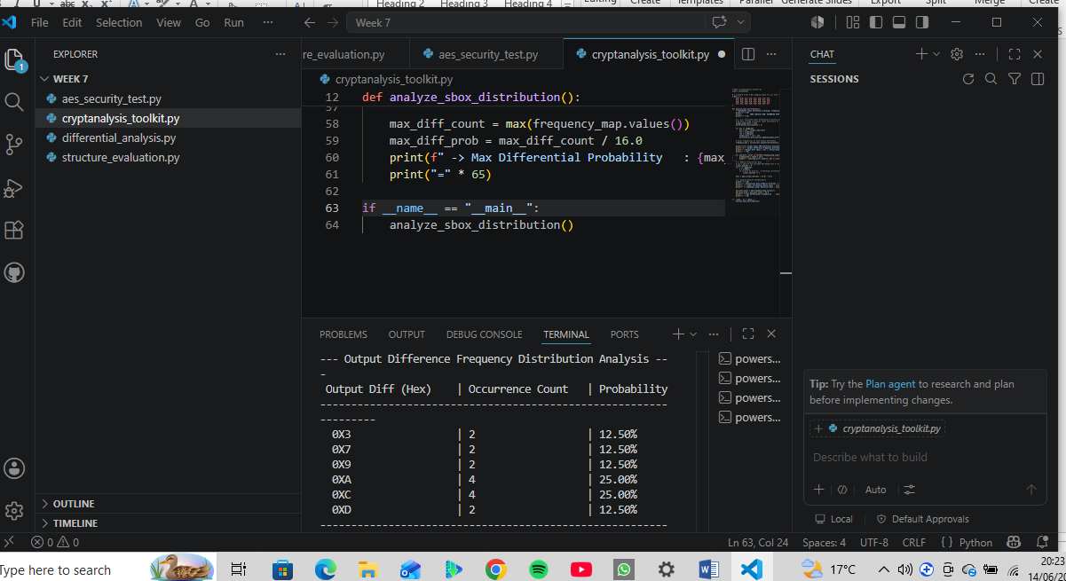
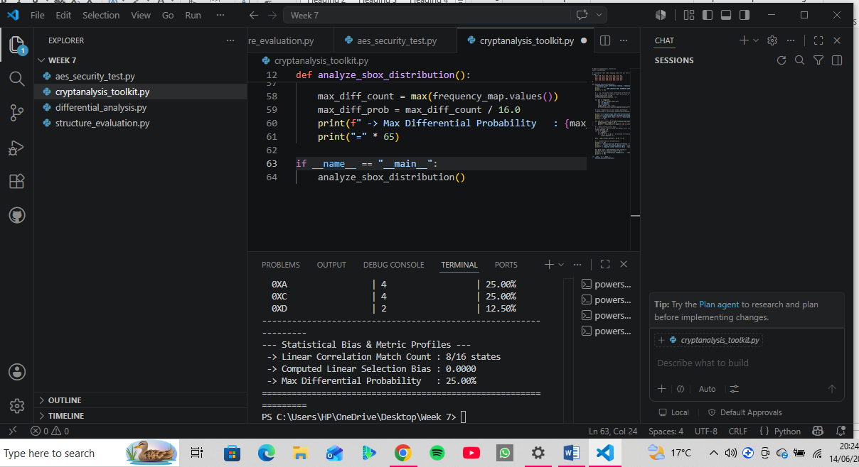

Challenge Task
Creating a Block Cipher Security Analyzer.
This comprehensive tool will integrate an elegant GUI using tkinter (matching the user-friendly interface style of your Week 6 simulator), compute the Avalanche Effect, track Difference Analysis, map out Frequency Distributions, and display full Statistical Reports directly on screen.

Fig 1:
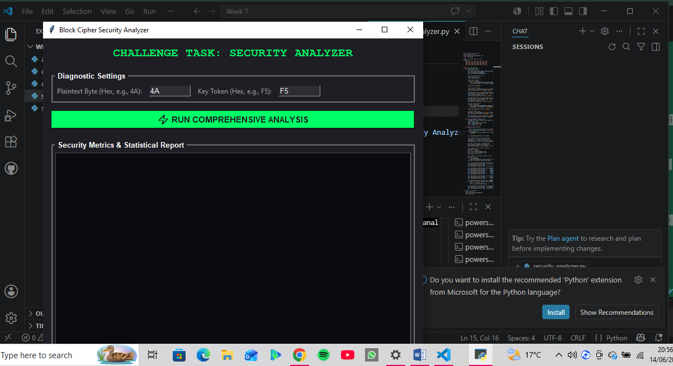

Fig 2:
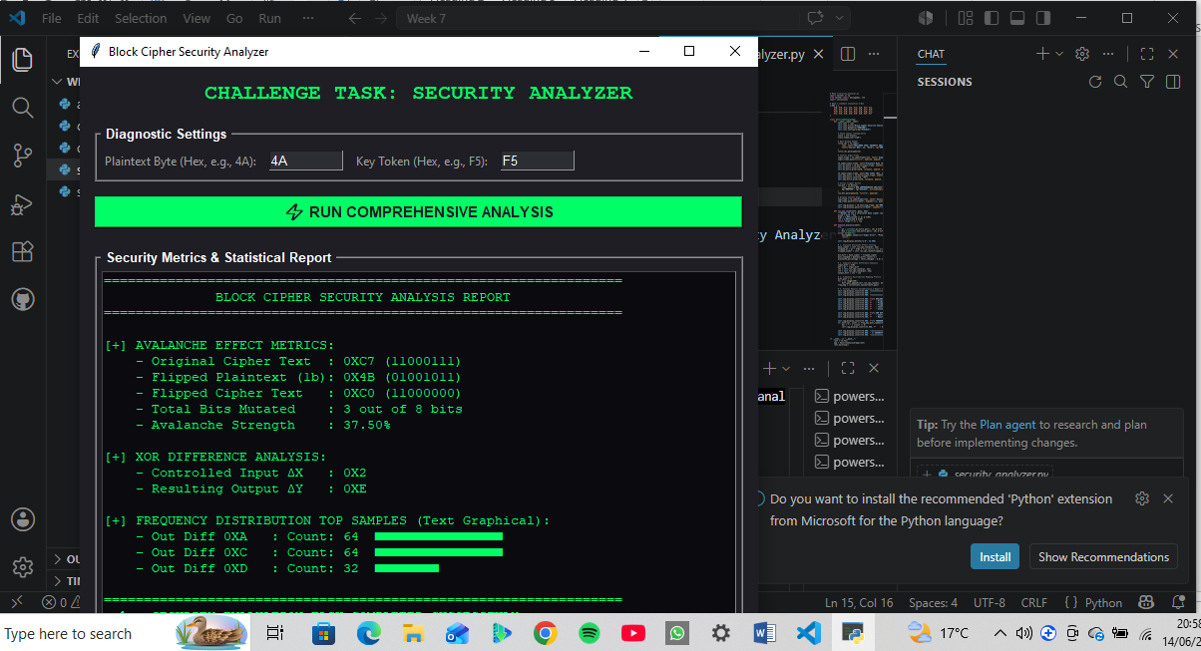

Reflection:
Week 7 focused on constructing practical laboratory suites to evaluate cryptographic algorithms. We developed programmatic scripts implementing the Advanced Encryption Standard (AES) to verify block cipher security, key handling, and initialization vectors (IVs). Additionally, structural evaluation scripts were built to stress-test implementation limits, alongside differential cryptanalysis tools designed to trace plaintext variations through cipher layers.

WEEK 8: Recap of PKI from Computer Cryptography Class.

Title: Public Key Infrastructure (PKI) and Digital Certificates

Practical Task- OpenSSL Certificate Inspection

Step 1: Download a Website Certificate

Fig 1
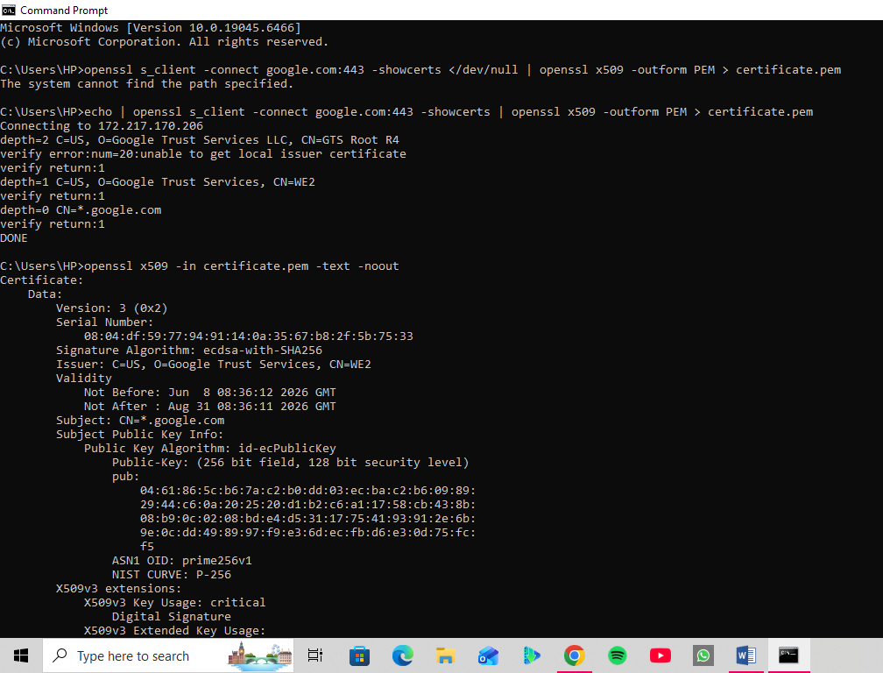

Fig 2
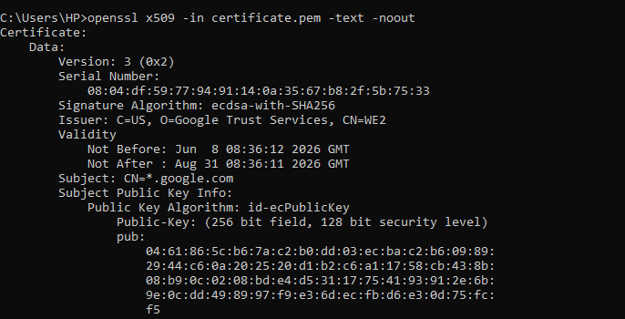

Assignment
Research a recent digital certificate security incident involving a Certificate Authority.
- Organization Involved
- ​The Certificate Authority: Entrust Inc., a legacy, high-profile global cybersecurity and identity management firm that operated several widely trusted Root CAs.
- ​The Gatekeepers: The major browser vendors (Google/Chromium, Mozilla, and Apple) who maintain the root trust stores built into modern operating systems and web browsers.
- Cause of the Incident
​Unlike a typical hack or breach, this incident was caused by systemic compliance and operational failures, not an external cyberattack.
- ​Repeated Mis-issuances: Between March and May 2024, Entrust was flagged for issuing certificates that violated the CA/Browser Forum Baseline Requirements (such as misconfiguring Extended Validation (EV) guidelines and using incorrect hashing algorithms like SHA-256 instead of SHA-384 for specific ECC keys).
- ​Failure to Revoke (The "Deliberate Decision"): When a CA discovers a mis-issued certificate, industry rules state they must revoke it within 24 hours. Entrust repeatedly missed these deadlines and deliberately chose to delay revocations to avoid disrupting their enterprise clients' operations.
- ​Historical Non-Compliance: This wasn't a one-off error. Google and Mozilla noted a "pattern of concerning behaviors" stretching back to 2020, citing a lack of urgency, poor incident handling, and broken promises regarding automation and remediation.

​3. Impact on Users
- ​The "Untrusted Connection" Domino Effect: Google, Mozilla, and Apple declared that any new TLS/SSL certificate issued by Entrust after November 2024 would be explicitly blocked. If a website attempted to use a new Entrust certificate, regular users visiting the site were greeted with glaring, severe security warnings (ERR_SSL_PROTOCOL_ERROR or "Your connection is not private").
- ​Operational Friction for Enterprise Clients: Thousands of massive corporations, banks, and government portals that historically relied on Entrust for their web encryption suddenly had to frantically audit their infrastructure and swap out their certificates to prevent their websites and internal Java applications from grinding to a halt.
​4. Corrective Actions Taken
- ​Browser Action (The Ultimatum): The major browser root stores officially revoked Entrust's status as a trusted partner for new certificate issuances.
- ​Entrust’s Emergency Pivot: Realizing they were losing global trust, Entrust had to partner with a competitor, SSL.com, to cross-sign and issue certificates through their roots so Entrust's enterprise customers wouldn't suffer immediate outages.
- ​Automation Upgrades: Entrust committed to completely re-engineering their compliance framework, introducing strict automated checks to prevent human error or manual overrides in certificate profiles.
​5. Lessons Learned for PKI Security
- ​Compliance is Not Optional: In cryptography, trust is absolute. Even the largest legacy companies will be completely cut off from the internet ecosystem if they fail to adhere strictly to open-standard baseline requirements.
- ​The Critical Need for Crypto-Agility: Organizations cannot afford to pin their entire security structure on a single CA. Businesses must maintain "crypto-agility"—the capacity to automatically and rapidly swap out digital certificates across thousands of servers (using protocols like ACME) within hours if a CA fails.
- ​Public Auditing Works: The incident proved that the public monitoring system (such as Certificate Transparency logs and community bug trackers like Mozilla's wiki) successfully holds powerful entities accountable, keeping the broader web safe from broken cryptographic guardrails.

TASK 2: Asymmetric Ciphers, Intractability, NP-Completeness, and the Diffie-Hellman Cryptosystem

Practical Task: Implementing Diffie- Hellman Key Exchange

Fig 1:
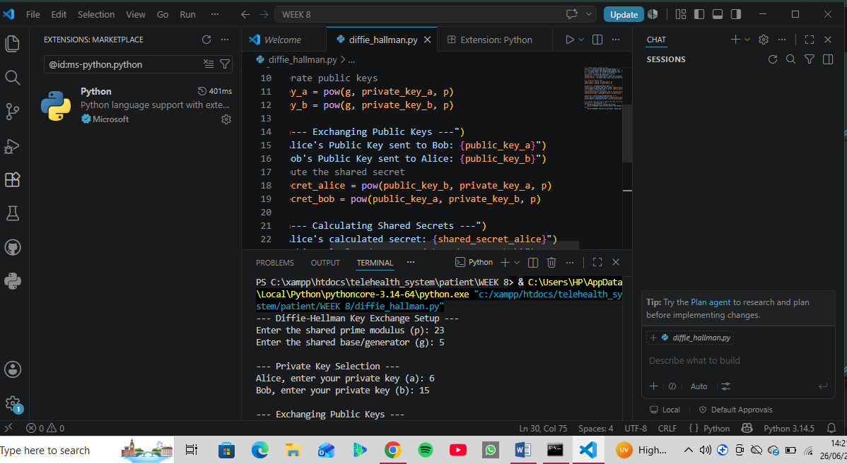
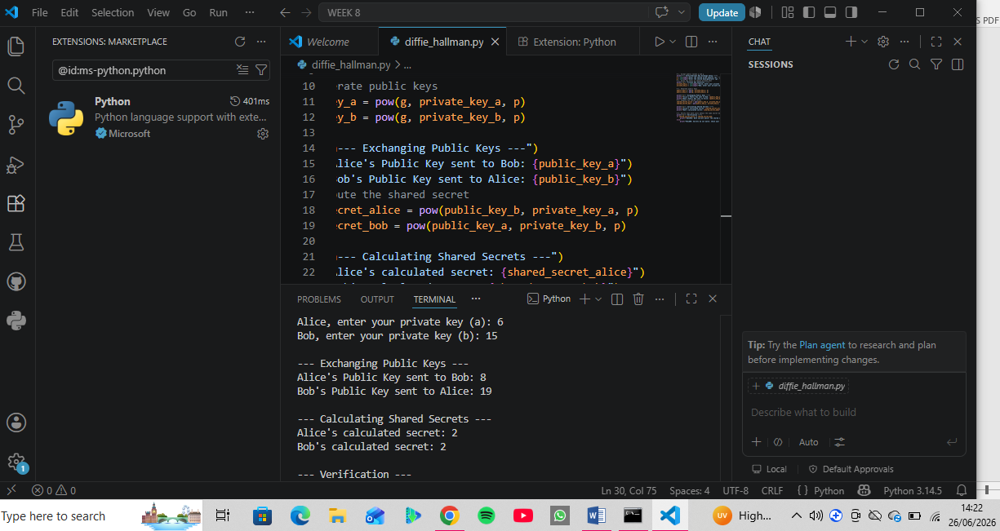
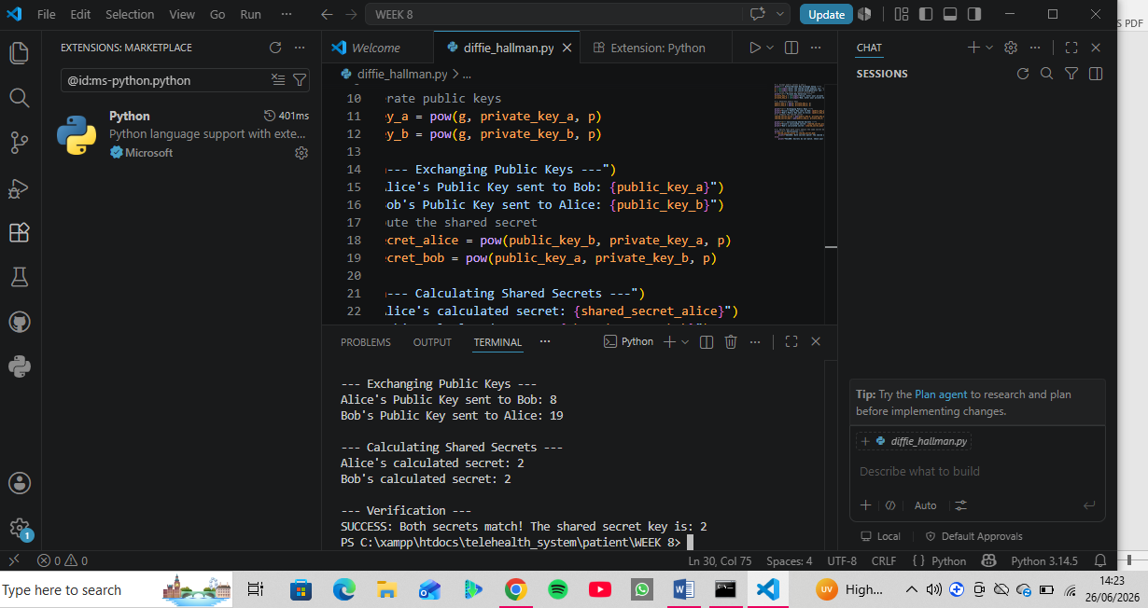

Assignment
Research and write a report on the role of the Diffie-Hellman Key Exchange in modern Internet Security.
- Definition: An asymmetric protocol allowing two parties to securely establish a shared secret key over an insecure channel without transmitting the key itself.
- ​Mechanism: Parties exchange public values derived via modular exponentiation (A = g^a \pmod p). They then combine their private keys with the received public keys to compute a matching secret (g^{ab} \pmod p).
- ​Security (DLP): Relies on the Discrete Logarithm Problem—it is computationally unfeasible for eavesdroppers to reverse engineer private exponents from public values.
- ​Application: Used in TLS 1.3 (via ECDHE) to provide Perfect Forward Secrecy.
- ​Challenges: Vulnerable to Man-in-the-Middle attacks if unauthenticated; solved using digital certificates.

Reflection:
This week focused on the foundational mechanics of public key infrastructure (PKI) and key exchange protocols. Through hands-on practice with OpenSSL, I successfully downloaded, inspected, and analyzed a live digital certificate, directly identifying critical fields like the Issuer, Subject, Signature Algorithm, and expiration parameters.
​Also, I researched on Certificate Authority compliance vulnerabilities and implemented a functional Diffie-Hellman Key Exchange simulation in Python using VS Code. Programming the modular exponentiation logic highlighted how the Discrete Logarithm Problem secures modern internet protocols like TLS, giving me a practical, dual-perspective understanding of how mathematical theory underpins real-world data encryption.

